2016/5/16 ResumeXifei Wu

xifei wu
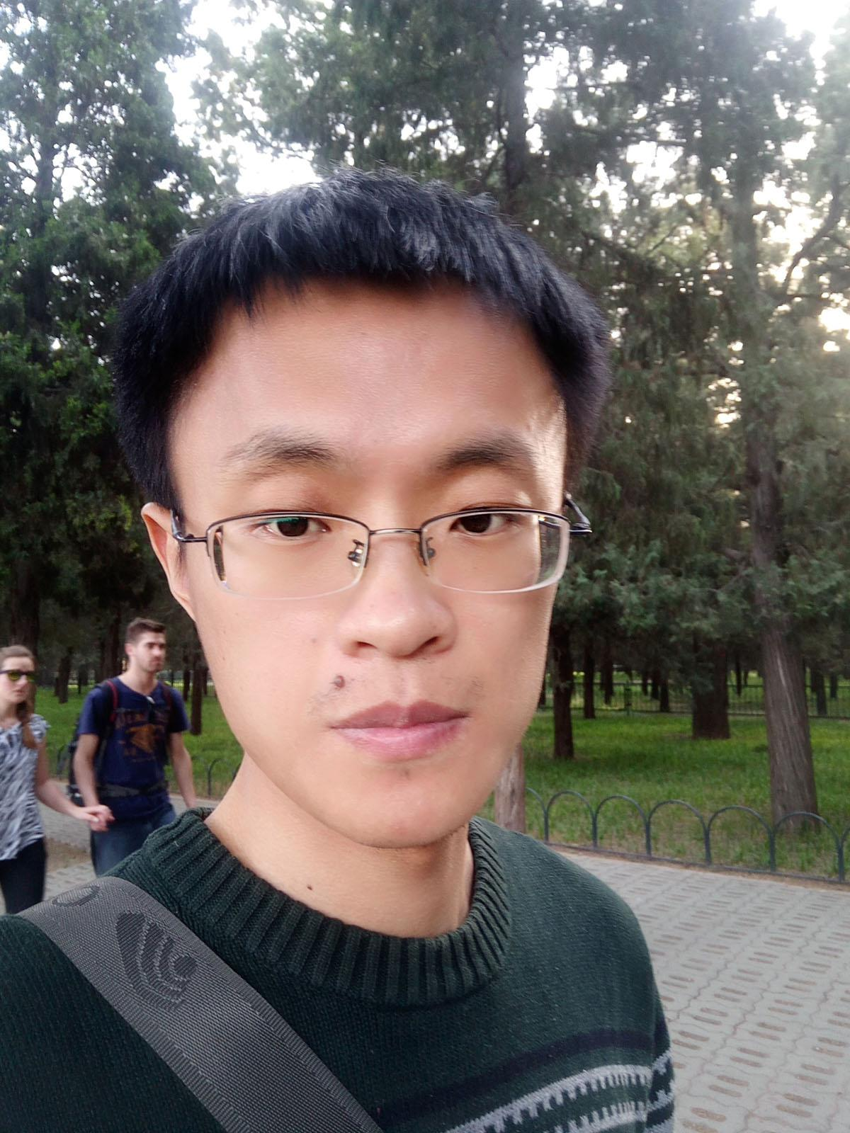
Frontend Developer

BORN: | Oct.9th, 1986
NATIVE PLACE: | Liaocheng, Shandong
GRADUATE: | Shandong University
MAJOR FIELD: | Computer Software and Theory
DEGREE: | Master
TELEPHONE: | 15712872803
EMAIL: | sduwxf@qq.com
URL OF THIS RESUME: | http://xifeiwu.github.io/

OBJECTIVE

My profession is software development on the period of both undergraduate and graduate. I take part in 'Electronic Design Contest for College Students' and win 'provincial second prize' in sophomore year, and work on embedded system for several months. My postgraduate major is graphic process, and I know GPU computing very well.

I have worked four years, three years for ISCAS and one year for Acadine Technologies. I worked on many platforms in ISCAS according to project needs, including Linux distribution, android, android watch, nwjs, meego, and focus on developing calendar app for H5OS when I was in Acadine.

I used to work on customizing Linux distribution, writing deb package, hybrid app developing on android platform, app development using nodejs or nwjs, developing H5 app on the platform of Firefox OS. More info will be shown in the following.

EDUCATION

Sep 2005 ‐ Jul 2009 College of Computer Science, Yantan University

Bachelor of Computer Science and Technology

take part in 'Electronic Design Contest for College Students' and win 'provincial second prize'.
My Thesis is 'The embedded FAT file system for NAND Flash'.
Sep 2009 ‐ Jul 2012 College of Computer Science, Shandong University

Master of Computer Software and Theory

take part in 'Accelerated Computing Competition in Chinese Universities', and the parallel program gets six times more speed on the platform of AMD HD5850
My thesis is 'A GPU Accelerated Algorithm for Video Super‐resolution based on Compressive Sensing', and it wins 'outstanding graduation thesis'
Develop many android games as my hobby
solitaire: https://github.com/xifeiwu/android‐solitaire
lianliankan: https://github.com/xifeiwu/android‐llk
eatdot: https://github.com/xifeiwu/android‐eatdot photopuzzle: https://github.com/xifeiwu/android‐photopuzzle
EXPERIENCE

Jul 2012 ‐ Aug 2015 Institute of Software Chinese Academy of Sciences engineer
custom Linux distribution using shell script.
https://github.com/xifeiwu/distro‐iso‐build
deb package for updating system written by python.
https://github.com/xifeiwu/python‐cdosupdate
Develop hybrid app on android. Sever side is written by nwjs, and client side

file:///D:/Linux/Acadine/xifeiwu.github.io/index_en.html 1/2

2016/5/16 ResumeXifei Wu

native call is got by the framework of Cordova, and the UI framework is

based on the third party project of appframework, the following repos are

some Cordova plugin.

network service discovery: https://github.com/xifeiwu/android‐ibp‐plugin‐
nsd

socket connection: https://github.com/xifeiwu/android‐ibp‐plugin‐socket
connection between phone and watch:
https://github.com/xifeiwu/android‐ibp‐plugin‐watch

A text parser written by PHP
a simple text parser written by php: https://github.com/xifeiwu/php‐
exam‐parser

server side app used for getting user feedback written by nodejs.
Sep 2015 ‐ Now Acadine Technologies

Frontend developer

Calendar is a big frontend app, it use many web components, such as, h5‐ header, h5‐input‐wrapper, h5‐dialog, h5‐toast, h5‐process, and some basic component such as, navigation‐manager, soft‐keys‐helper. It covers many h5 technologies, such as indexedDB, js worker, promise.
Calendar use page.js for page direction, and use iCalendar protocol for communication between local and online, and several third party project is also used, such as ical.js, caldav.js.

Calendar app for Firefox OS: https://github.com/xifeiwu/calendar
I am familiar with js and css, including web component, indexedDB, js worker, css flex display, css animation, css generated content, pesudo class(element) and so on.
used to work with jquery, requirejs, bootstrap, appframework.
SKILLS

Languages used | JS/CSS/HTML | C/C++ | Java
 | PHP | Shell | Python
Used to work on | Frontend development |  | hybrid or native app development
 |  |  | on android platform
 | Linux distribution customization, |  | server side development using
 | build and manage deb repo server |  | nodejs
 | development on embedded system |  | parallel computing on the platform
 |  |  | of GPU
 | shell scirpt, dbus, Git
SUMMERY

I used to work on many platforms and fields and focus on frontend development for nearly two years. I love software development and want to focus on specific field for a long time to accumulate more efficiency and ability.

file:///D:/Linux/Acadine/xifeiwu.github.io/index_en.html 2/2

